 | Curriculum: ACCPi7.1  Subject: HDJ-DWMX  Duration: 120 minutes  Total Marks: 25  Exam Date: 31-Dec-08

MODULE TEST PRACTICAL

If this rule is violated, the examination will be ignored.

Question 1 [8.0]
Create a form as shown in Figure 1 using HTML and Dreamweaver : [8.0]
Note : Students must save his/her programs as following rules:
- Put all files for Question 1 into QUESTION1 Folder.
- Put all files for Question 2 int QUESTION2 Folder.

Figure 1
- When user Click on Reset Button, all field must be cleared.
- When user Click on Submit Button, following validations will be performed:
- Email can not be empty.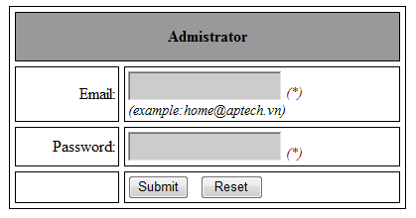
- Email must be format.(example: admin@aptech.vn).
- Password can not be empty.
- Password must include full character as: a-z; A-Z;1-9, ;@;#;$;?;~ (each character appears at least 1 times)
- If value are invalid, display an error message corresponding.(use alert function)
- If value are valid and email equal to ‘admin@aptech.vn’ , password equal to ‘aA1~@#$?’ show the productadnew.html page. (as shown in Figure 2).
Question 2 [17]
Create a form as shown in Figure 2 using HTML and Dreamweaver : [5]
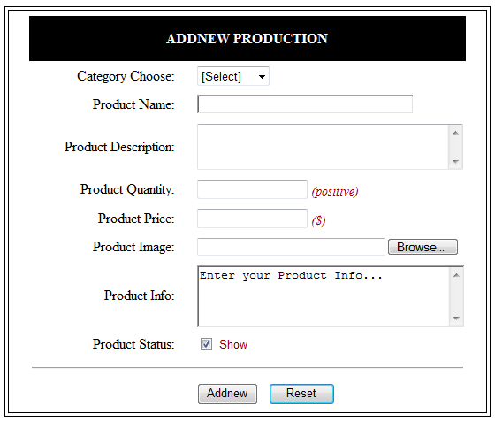
Figure 2
- When user C l ick on Reset Button, all field must be cleared, field Product Info is value “Enter your Product Info…..”. [0.5]
- Change the color of ‘ADDNEW PRODUCTION’ when the mouse is moved over it to RED, and back to original color when the mouse pointer moves out of it. [0.5]
- Category choose drop down list has the follwing option: [1.0]
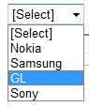
User must select 1 category
- [1.0]
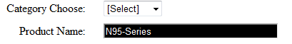
- When user Click on Product Status check: [1.0]
- If Product Status is true, display ‘show’ as Figure 2 else display ‘hidden’.
Example: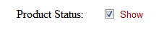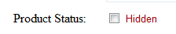
- When user Click on Addnew Button, following validations will be performed :
(NOTE: If value are invalid, display an error message corresponding)
- Category choose must select.P [1.0]
- Product Name only contain characters, digits, minus sign , space and not empty. (a-z,A-Z, 0-9, ,-,_). [1.0]
- . [1.5]
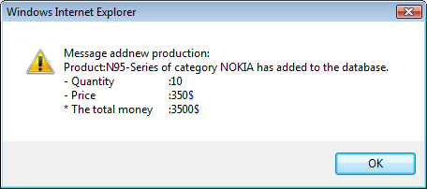
where,
  - ‘N95-series’ from the product name.
  - ‘NOKIA’ select category.
  - ‘10’ from the Product Quantity.
  - ‘350’ from the Product Price.
  - ‘3500$’ calculated from [Product Name] * [Product Price].

